Name : Tushar Pathak
Registration Number : 230905396
Roll Number : CSE6B-48
Week Num : 7

LAB 8 : RD PARSER FOR ARRAY DECLARATION AND EXPRESSION STATEMENTS
Q1) Design the recursive descent parser to parse array declarations and expression statements with error
reporting.
Subset of grammar 7.1 is as follows:

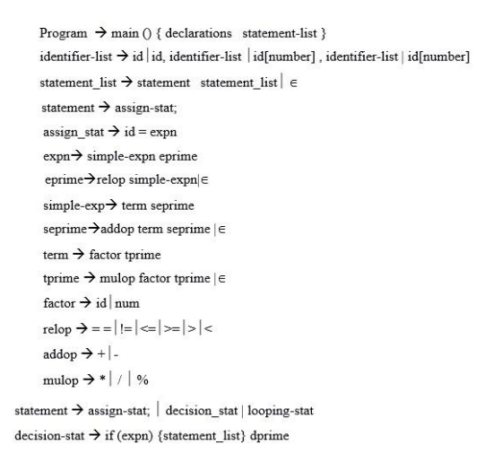

Code:
#include <stdio.h>
#include <stdlib.h>
#include <string.h>
#include <ctype.h>

typedef struct {
char lexeme[100];
char type[20];
int row;
int col;
} Token;

FILE *fp;
Token currentToken;
int row=1,col=0;

char *keywords[]={"int","char","main",NULL};

/* ----------- Function Declarations ----------- */

Token getNextToken();
void program();
void declarations();
void data_type();
void identifier_list();
void idprime();
void statement_list();
void statement();
void assign_stat();
void expn();
void eprime();
void simple_expn();
void seprime();
void term();
void tprime();
void factor();

void match(char *expected);
void error(char *expected);

/* ----------- Error Function ----------- */

void error(char *expected){
printf("\nSyntax Error at Row %d Column %d\n",currentToken.row,currentToken.col);
printf("Expected: %s\n",expected);
printf("Found: %s\n",currentToken.lexeme);
exit(1);
}

/* ----------- Match Function ----------- */

void match(char *expected){
if(strcmp(currentToken.lexeme,expected)==0)
currentToken=getNextToken();
else
error(expected);
}

/* ----------- Keyword Check ----------- */

int isKeyword(char *str){
for(int i=0;keywords[i]!=NULL;i++)
if(strcmp(str,keywords[i])==0)
return 1;
return 0;
}

/* ----------- Lexical Analyzer ----------- */

Token getNextToken(){
Token t;
char ch;
int i=0;

ch=fgetc(fp);
col++;

while(isspace(ch)){
if(ch=='\n'){ row++; col=0; }
ch=fgetc(fp);
col++;
}

t.row=row;
t.col=col;

if(isalpha(ch)){
while(isalnum(ch)){
t.lexeme[i++]=ch;
ch=fgetc(fp);
col++;
}
t.lexeme[i]='\0';
fseek(fp,-1,SEEK_CUR);
col--;

if(isKeyword(t.lexeme))
strcpy(t.type,"KEYWORD");
else
strcpy(t.type,"ID");

return t;
}

if(isdigit(ch)){
while(isdigit(ch)){
t.lexeme[i++]=ch;
ch=fgetc(fp);
col++;
}
t.lexeme[i]='\0';
fseek(fp,-1,SEEK_CUR);
col--;
strcpy(t.type,"NUM");
return t;
}

if(ch==EOF){
strcpy(t.lexeme,"EOF");
strcpy(t.type,"EOF");
return t;
}

t.lexeme[0]=ch;
t.lexeme[1]='\0';
strcpy(t.type,"SYMBOL");
return t;
}

/* ----------- Grammar Functions ----------- */

void program(){
match("main");
match("(");
match(")");
match("{");

declarations();
statement_list();

match("}");
printf("\nParsing Successful!\n");
}

/* declarations → datatype id_list ; declarations | ε */

void declarations(){

if(strcmp(currentToken.lexeme,"int")==0 ||
strcmp(currentToken.lexeme,"char")==0){

data_type();
identifier_list();
match(";");
declarations();
}
}

/* datatype */

void data_type(){

if(strcmp(currentToken.lexeme,"int")==0)
match("int");
else if(strcmp(currentToken.lexeme,"char")==0)
match("char");
else
error("int or char");
}

/* identifier list with arrays */

void identifier_list(){

if(strcmp(currentToken.type,"ID")==0){
match(currentToken.lexeme);
idprime();
}
else
error("identifier");
}

void idprime(){

if(strcmp(currentToken.lexeme,"[")==0){

match("[");
if(strcmp(currentToken.type,"NUM")==0)
match(currentToken.lexeme);
else
error("number");

match("]");
}

if(strcmp(currentToken.lexeme,",")==0){
match(",");
identifier_list();
}
}

/* statement list */

void statement_list(){

if(strcmp(currentToken.type,"ID")==0){
statement();
statement_list();
}
}

/* statement */

void statement(){

assign_stat();
match(";");
}

/* assignment */

void assign_stat(){

if(strcmp(currentToken.type,"ID")==0){
match(currentToken.lexeme);
match("=");
expn();
}
else
error("identifier");
}

/* expressions */

void expn(){
simple_expn();
eprime();
}

void eprime(){

if(strcmp(currentToken.lexeme,"<")==0 ||
strcmp(currentToken.lexeme,">")==0){

match(currentToken.lexeme);
simple_expn();
}
}

void simple_expn(){
term();
seprime();
}

void seprime(){

if(strcmp(currentToken.lexeme,"+")==0 ||
strcmp(currentToken.lexeme,"-")==0){

match(currentToken.lexeme);
term();
seprime();
}
}

void term(){
factor();
tprime();
}

void tprime(){

if(strcmp(currentToken.lexeme,"*")==0 ||
strcmp(currentToken.lexeme,"/")==0 ||
strcmp(currentToken.lexeme,"%")==0){

match(currentToken.lexeme);
factor();
tprime();
}
}

void factor(){

if(strcmp(currentToken.type,"ID")==0)
match(currentToken.lexeme);

else if(strcmp(currentToken.type,"NUM")==0)
match(currentToken.lexeme);

else
error("identifier or number");
}

/* ----------- Main ----------- */

int main(){

fp=fopen("input.txt","r");

if(fp==NULL){
printf("File not found\n");
return 1;
}

currentToken=getNextToken();
program();

fclose(fp);
}
Input.txt
main(){
int a[],b; //expected error here a[size], size not given
a = 5;

}

Output:

